Partner system configuration
Below is a basic configuration of the ONNA configurator for a single video door entry panel
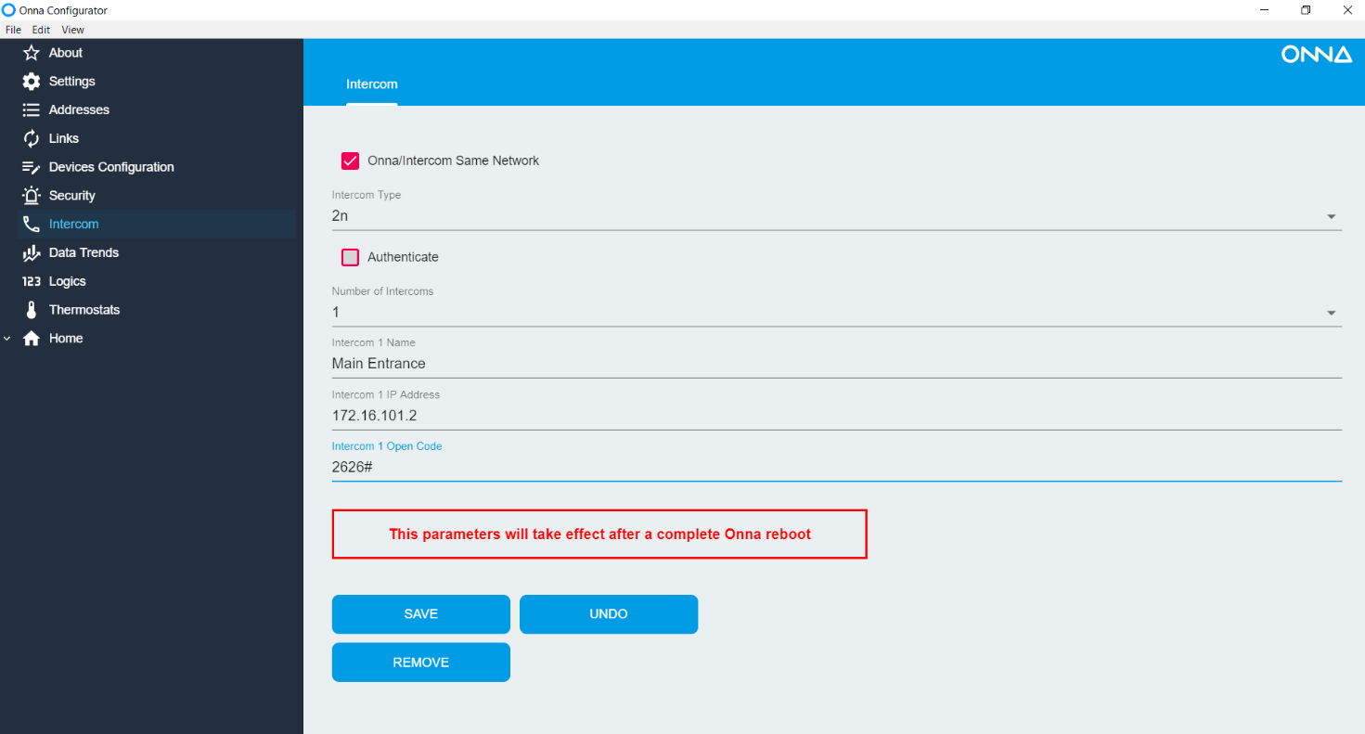
You must specify the IP address of the panel and the number and the door opening number followed by a #
We will specify the configuration for the IP address of the screen
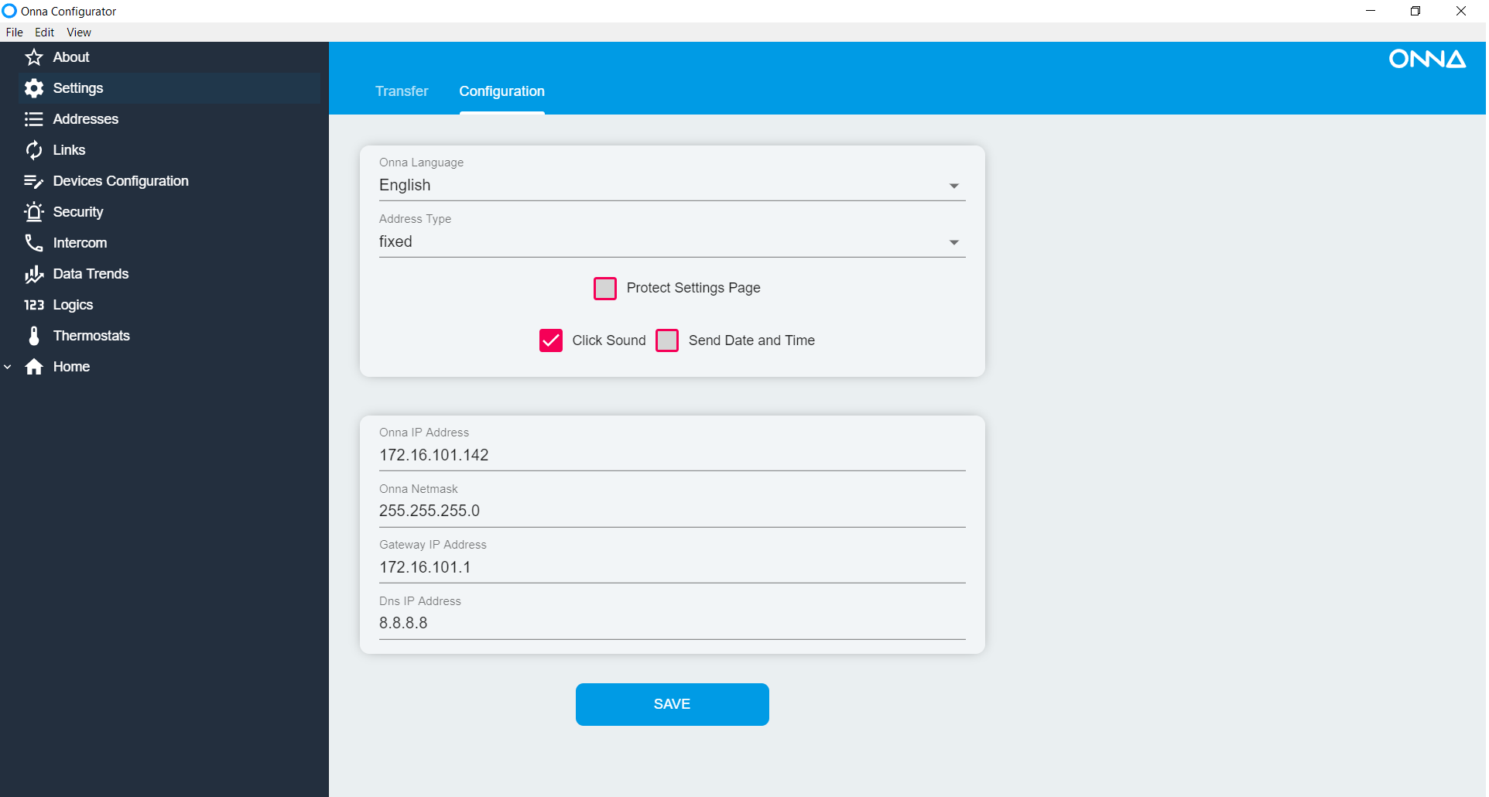
The display may need to be restarted for this setting to take effect.
The Onna/Intercom Same Network refers to the configuration used in buildings apartments with networks interconnected by security routers. Not detailed in this manual

