Summary
1. 2N® ITEM CODES 2
2. SYSTEM TYPES 4
3. TECHNICAL SPECIFICATIONS 7
3.1 Device power supply 7
3.2 Connection to the LAN network 7
3.3 Connectors/Terminal blocks 7
4. PRELIMINARY OPERATIONS 7
4.1 Recovery of the video door phone IP address 7
4.2 Access to the configuration page 8
5. BASIC VIDEO DOOR PHONE CONFIGURATION 10
5.1 Choice of language 10
5.2 Parameter configuration 10
6. VIDEO DOOR PHONE OUTPUT CONFIGURATION 15
7. VIDEO DOOR PHONE INPUT CONFIGURATION 16
8. VIDEO DOOR PHONE MANAGEMENT VIA 2N® APP 17
8.1 Video door phone configuration for use with the APPs 17
APP settings on Mobile Apple devices 17
APP installation on mobile Android devices 18
9. RESETTING OF DEFAULT PARAMETERS 19
10. AVE TOUCH SCREEN CONFIGURATION 19
11. GATE AND LIGHTS OUTPUT CONNECTION 20

WARNING:

The DOMINAplus home automation supervisory devices cannot manage Intercommunicating Calls.
Therefore it is possible to receive Video Door Phone calls only from external stations.

2N® ITEM CODES
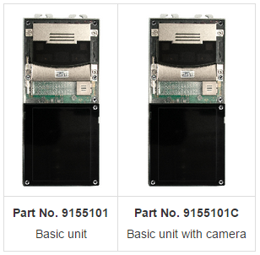

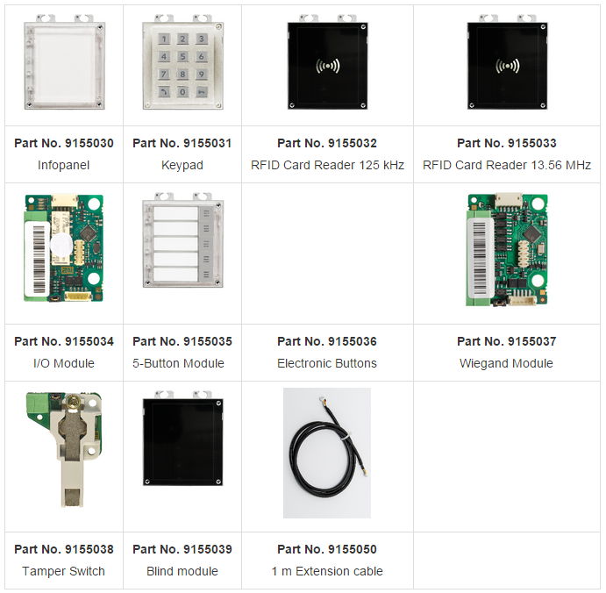

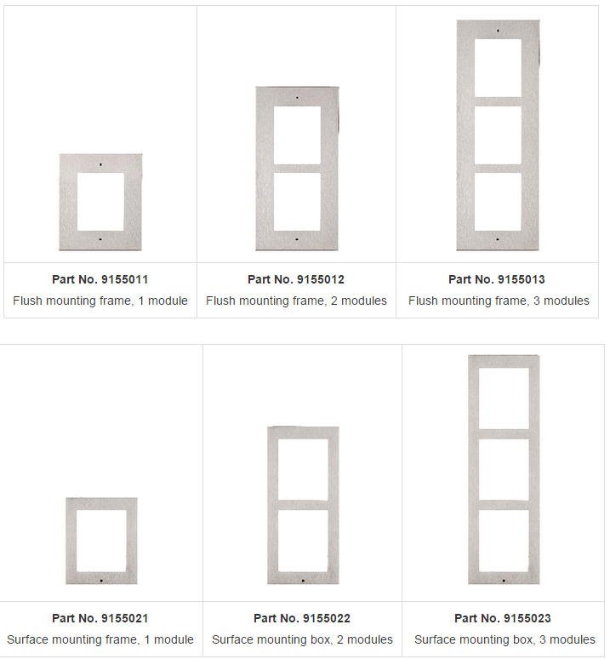

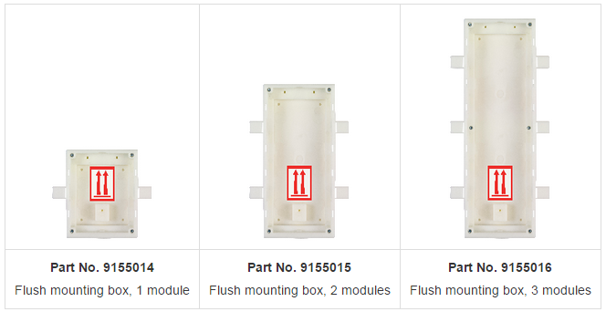

N.B.: The 2N material is only partly marketed directly by AVE S.P.A.
For any information of a technical/commercial nature, you can directly call the 2N TELEKOMUNIKACE representative for Italy:

- EDS LAN via Damiano Chiesa, 20
20871 Vimercate (Monza Brianza, Italy)
Tel. 039/699981

SYSTEM TYPES

Single-call diagram (single-family)
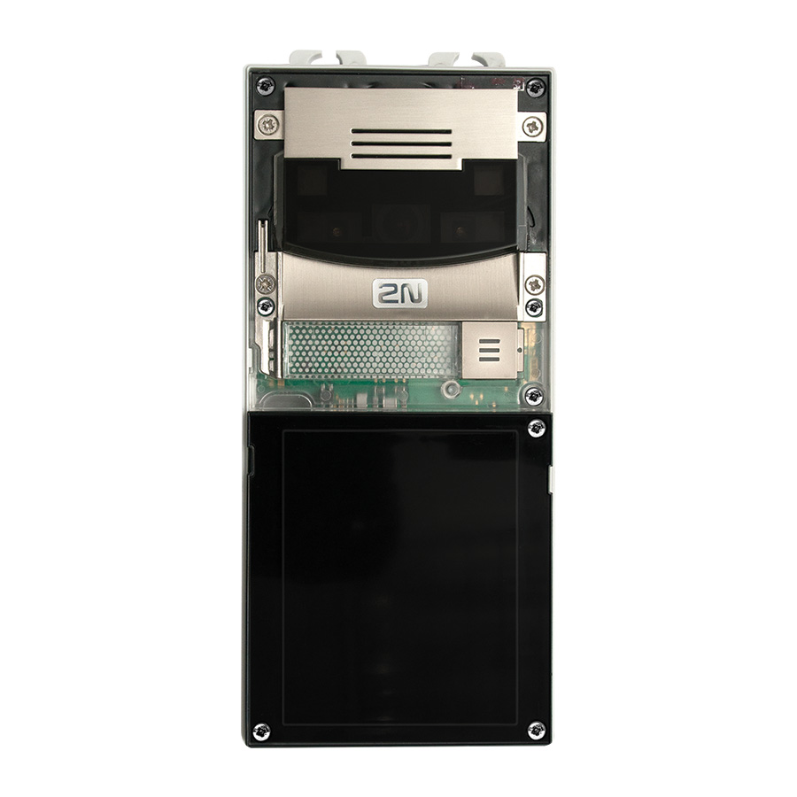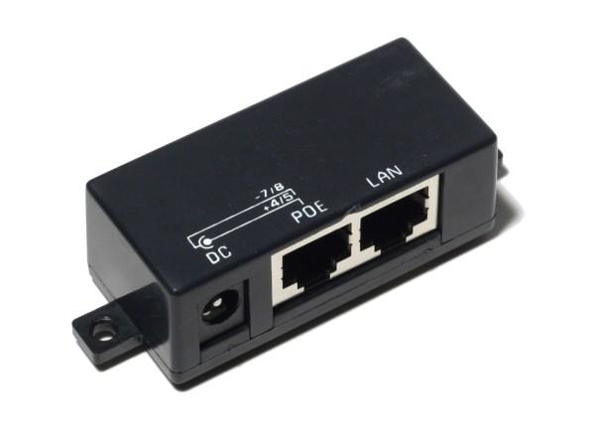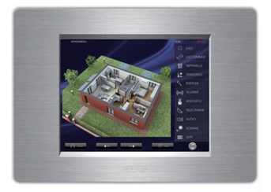
AVE Item N°: TS04V
AVE Item N°: TS04V
ADSL (Broadband) Line
Power Injector (PoE)
Router (NO MODEM)
ADSL (Broadband) Modem

Multi-call diagram

Router (NO MODEM) Flat 1

Network Switch
Power Injector (PoE)
Router (NO MODEM) Flat 2
Router (NO MODEM) Flat xx
ADSL (Broadband) Modem

ADSL (Broadband) line

ADSL (Broadband) modem

ADSL (Broadband) line

TECHNICAL SPECIFICATIONS

For any further information regarding Video Door Phone stations that is not contained in this manual, please refer to the technical manual issued by the 2N® manufacturer.

Power supply:12V±15%/2ADC or PoE
PoE: PoE 802.3af (Class 0 – 12.95W)
LAN: 10/100BASE-TX con Auto-MDIX, RJ-45
Relay output: NC/NO contacts, max 30V/1A AC/DC
Active output: 8V – 12V DC/400mA

Device power supply
The 2N® Video Door Phone can be powered by means of an external 12V/2ADC power supply unit or directly by the LAN cable through a PoE.

Connection to the LAN network
The 2N® Video Door Phone connection to the Local Area Network (LAN) is possible through a RJ-45 connector (cat.5 or higher).

Connectors/Terminal blocks
The interface connector diagram is shown below:
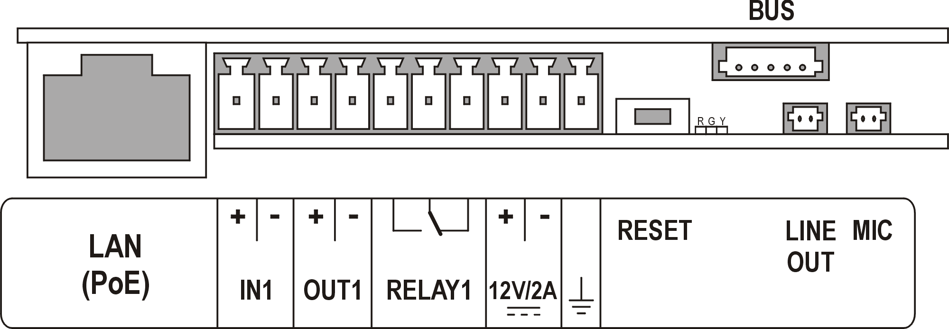

PRELIMINARY OPERATIONS

Recovery of the video door phone IP address
In order to know the 2N® Video Door Phone IP address, it is necessary to follow the steps below:

- Connect the device from the power supply (or, if already connected, disconnect and connect again);
- Wait for the second acoustic signal and press the call button 5 consecutive times;
- The Video Door Phone will display its IP address;
- If the IP address shown is 0.0.0.0, then the device is not connected to the LAN network;
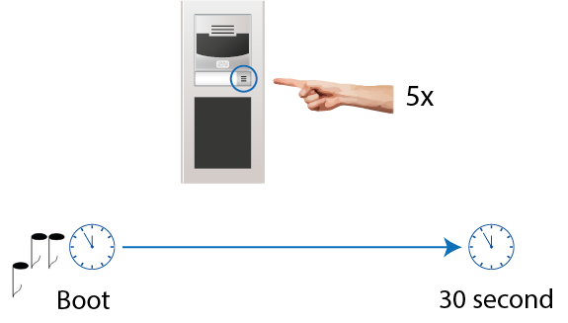

Access to the configuration page
In order to access the configuration page, it is necessary to connect a PC onto the same network as the device and carry out the operations shown below:

- Launch your internet browser;
- Enter the Video Door Phone IP address;
- Enter username and password;

DEFAULT PARAMETERS FOR ACCESS TO THE 2N® VIDEO DOOR PHONE

USERNAME: Admin
PASSWORD: 2n

THE PC AND THE VIDEO DOOR PHONE MUST BE SET WITH NETWORK PARAMETERS THAT ENABLE THE PROPER CONNECTION.

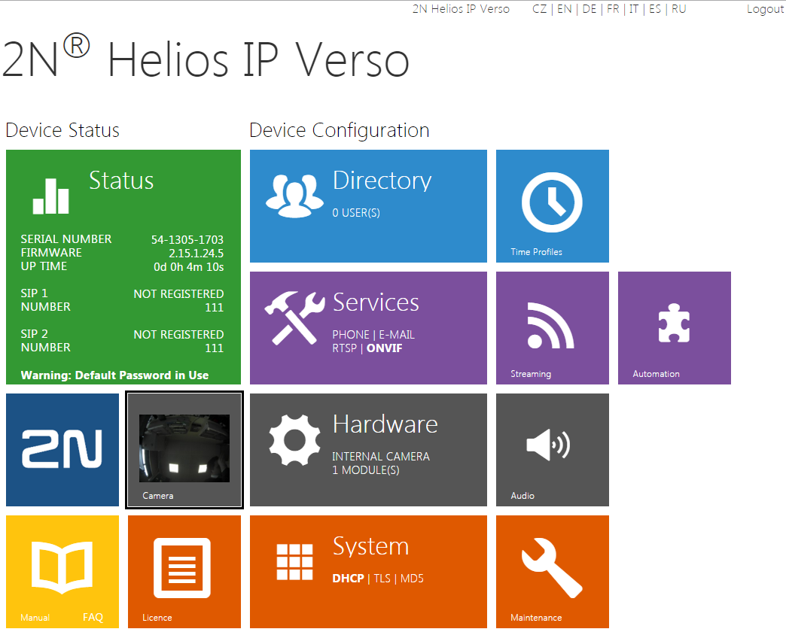

BASIC VIDEO DOOR PHONE CONFIGURATION

Choice of language
From the home page of the Video Door Phone, it is possible to select the language of the interface by pressing the left button on the mouse on one of the options shown below:

Parameter configuration
All the information shown below may vary depending on the firmware version of the device.
The guide that is currently available was created with the following hardware and firmware versions:
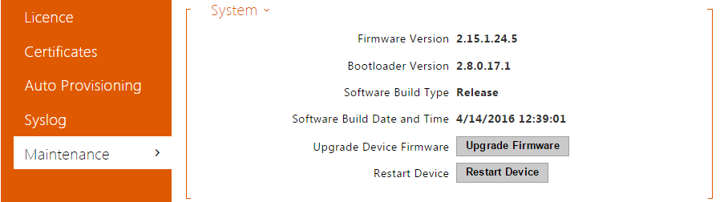

As for the configuration of the parameters, follow the instructions given below:

- LICENCE ACTIVATION
The activation of the licence makes it possible to access the advanced features of the device, some of which are necessary in order to interface with the Ave touch screen home automation devices.

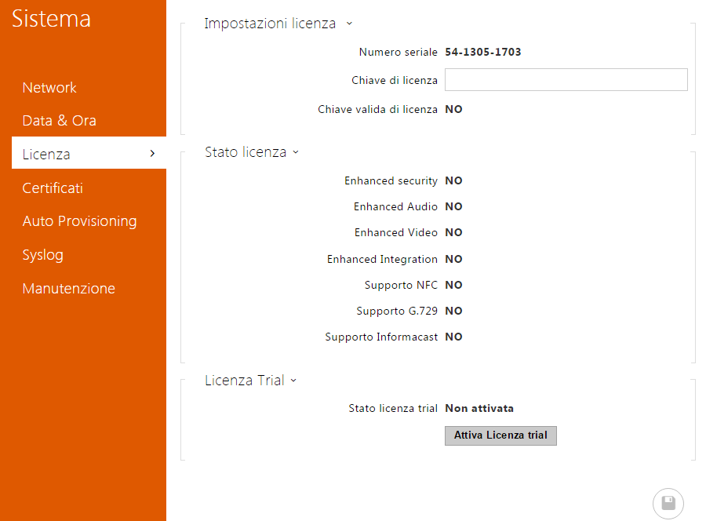
- If the Video Door Phone has been purchased from AVE, contact the freephone number 800 015072 to obtain the licence unlock code.
- Enter the unlock code provided into the “Licence Key” field.
- If it is not possible to obtain the right licence code, click on the “Activate licence trial” button to enable all the features for a 30-day trial period.
- Press the “Save” button to make these modifications effective.

- SYSTEM MENU
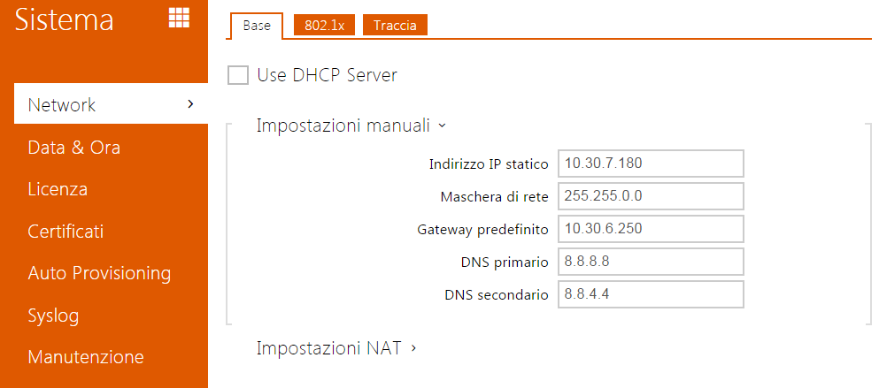
- Modify the IP configuration protocol of the device from the DHCP server to a fixed address by removing the checkmark from “Use DHCP Server”;
- Enter the parameters to configure the static IP address.

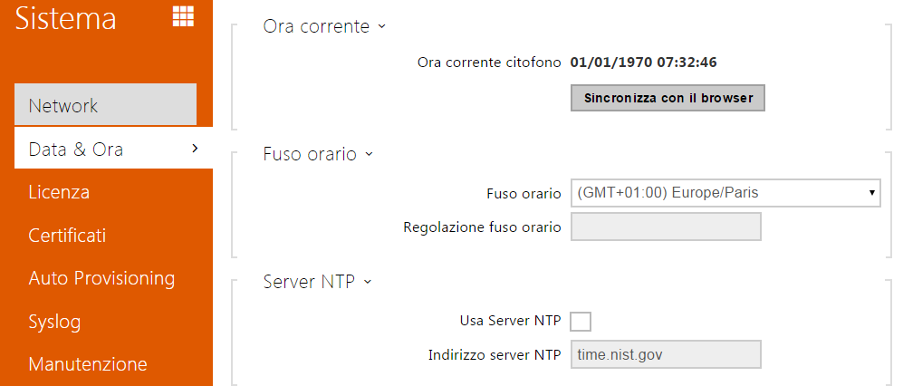
- Update the date and time of the device.

- DIRECTORY MENU
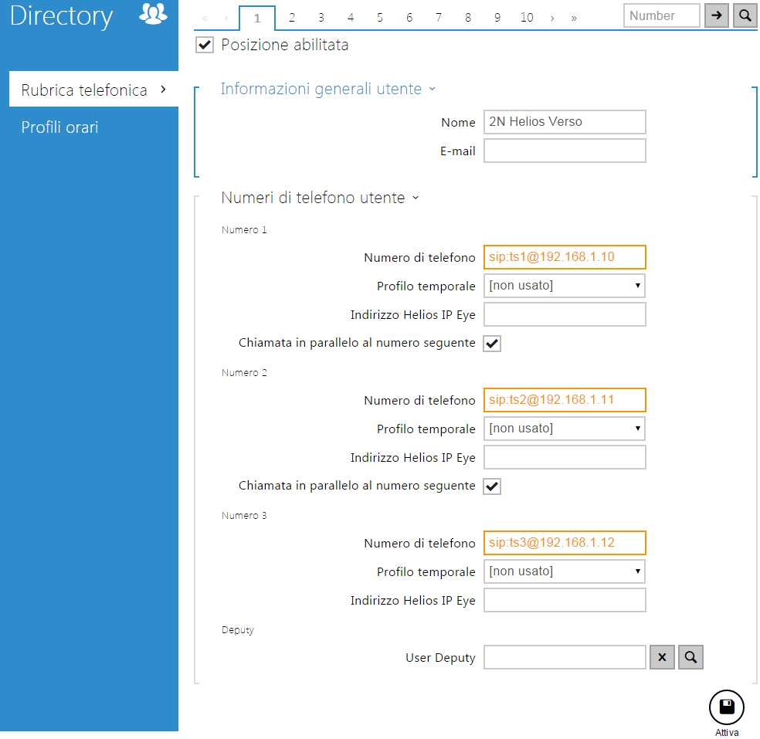
- Enable the number of the position desired (the position corresponds to the call button).
- Enter the data relating to the TS to be called into the “Telephone number” field. The string must contain:

sip:name@address

where:
name = touch screen name.
address = touch screen IP address.
- Press the “Activate” button to save the configuration.
- If there is more than n.1 touch screen present, it is necessary to:
- Select the parallel call feature
- Repeat the procedure shown in point 2 for each of the touch screens installed.
Obviously, the name and IP address must be different for each touch screen installed.

WARNING: The maximum number of configurable devices (IP addresses of Touch screens + any APPs) per each station in the directory is 3. In case there are more than n.3 internal stations, it is necessary to configure the “User Deputy” parameter so that calls are also forwarded to other positions in the directory, into which the IP addresses of the remaining internal stations will be inserted.

- SERVICE MENU
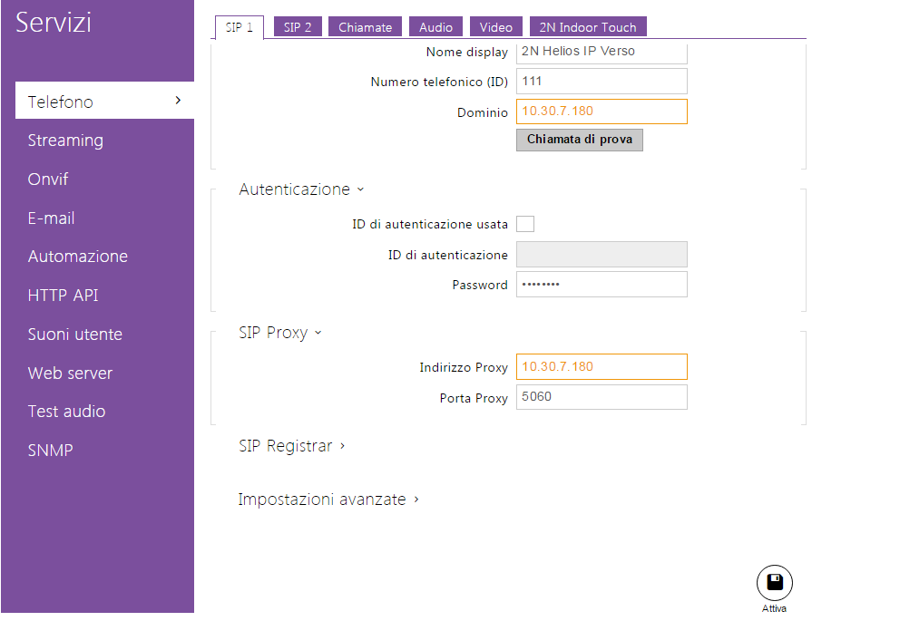

- Enter the IP address of the 2N® Video Door Phone into the fields below:
- Domain;
- Proxy address;

To recover the Video Door Phone IP address, please refer to paragraph 4.1.

- Set the Proxy Port value to 5060.

- Press the “Activate” button to save the configuration. Carry out the same operations also for the SIP2 card.

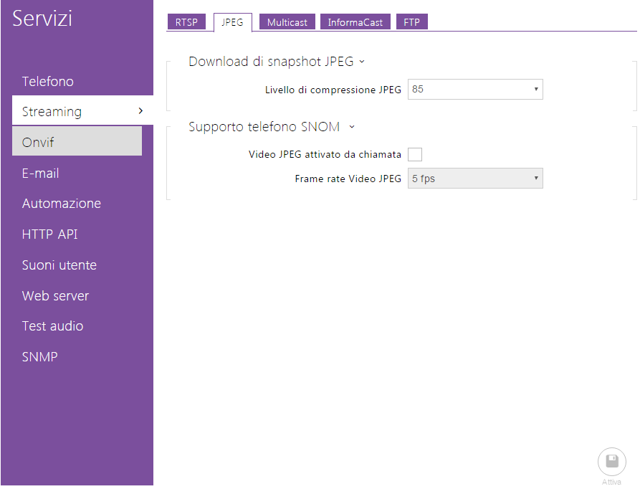
- In the
Services/Streaming/JPEG menu, set the level of JPEG compression to 85;
- Press the “Activate” button”

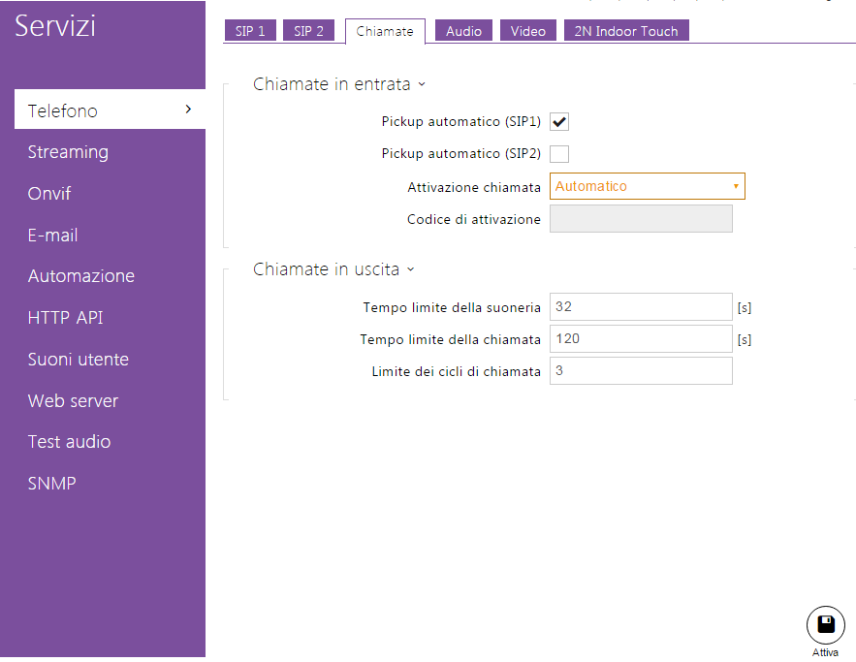
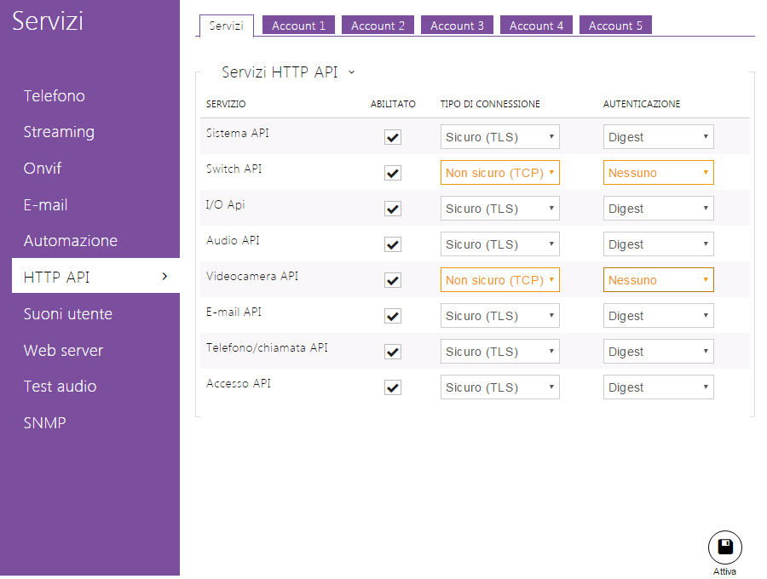
- In the Services/Telephone/Calls menu:
- Enable the automatic answering service;
- Set the “Call Activation” feature to Automatic
- Press the “Activate” button

- Modify:
- Api Switch = Not secure;
- Api Camera = Not secure
- Authentication for both parameters = None
Press the “Activate” button

VIDEO DOOR PHONE OUTPUT CONFIGURATION
The 2N® Video Door Phone has n.2 on-board outputs:
Relay 1 = output directly controlled by a relay contact.
Output 1 = output controlled by a transistor output.

The configuration of the same is shown below:
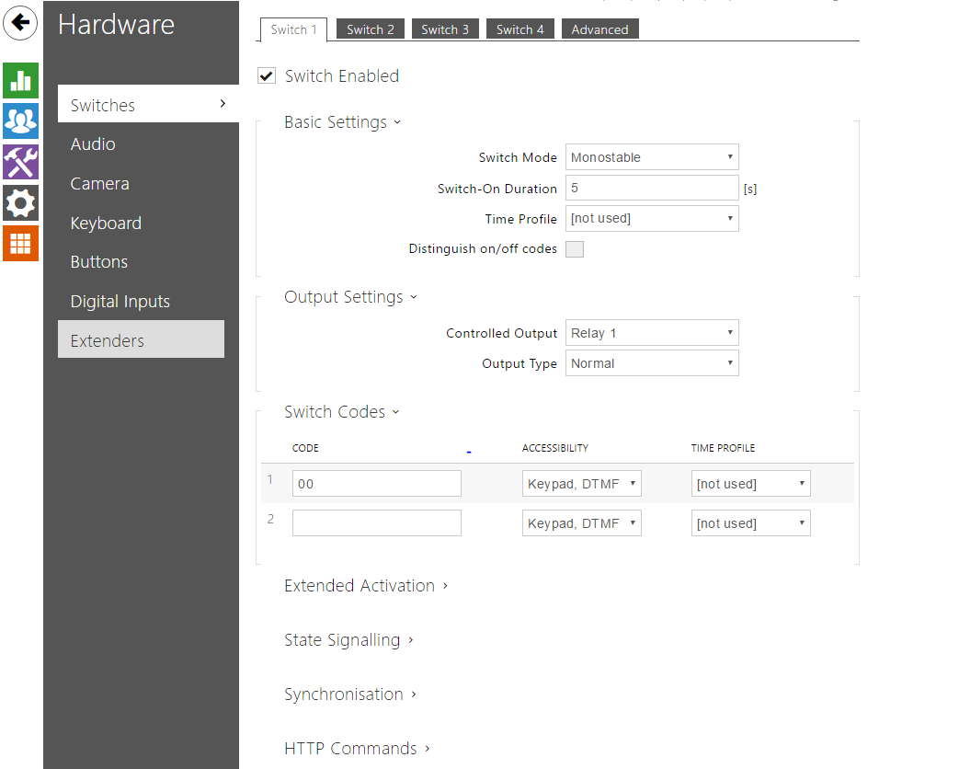
Access the “Hardware” menu.
- Enable the Switch desired;
- Select the type of output (monostable or bistable);
- Set the contact closure time;
- Define which of the two outputs to associate with;
- If necessary, repeat the procedure, also for the second Switch;
- Press the “Activate” button;

VIDEO DOOR PHONE INPUT CONFIGURATION
The 2N® Video Door Phone has an “IN1” on-board input, that can be used for several signalling or command functions. For example, it can be used to activate a Video Door Phone output (such as the electric lock) following the closure of an NA or NC contact. In this case, it will be necessary to connect the contact between the “+” and “-“clamps of the IN1 input.

The configuration for this use is shown below:
Access the “Hardware” menu.
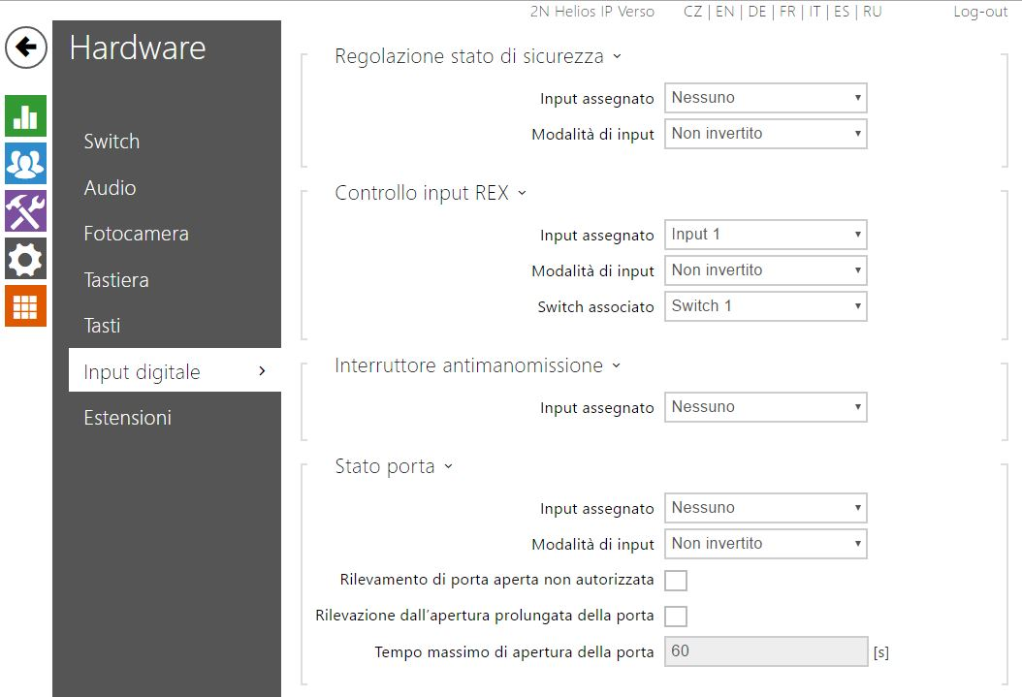
- Select the input desired (Input 1 for the integrated input of the Video Door Phone);
- Select the input mode (“Inverted “or “Not inverted” refer to “NC” or “NA”);
- Define which output switch must be controlled;
- Press the “Activate” button;

VIDEO DOOR PHONE MANAGEMENT VIA 2N® APP
The 2N® Video Door Phone can be controlled via an APP from devices with either an Apple or Android IOS operating system.

The APP, that is neither supplied nor can be modified by AVE S.P.A., can be downloaded from either the Apple APP STORE or from the Google Play Store and it is called 2N® Helios IP Mobile. All parameters below refer to the firmware ver.2.15.1.24.5. With subsequent firmware, it is possible that certain parameters are either hidden and/or enabled by default.

The APP works only with a local wireless connection.

Video door phone configuration for use with the Apps

After each action shown below, press the “Activate” button at the bottom of the page.

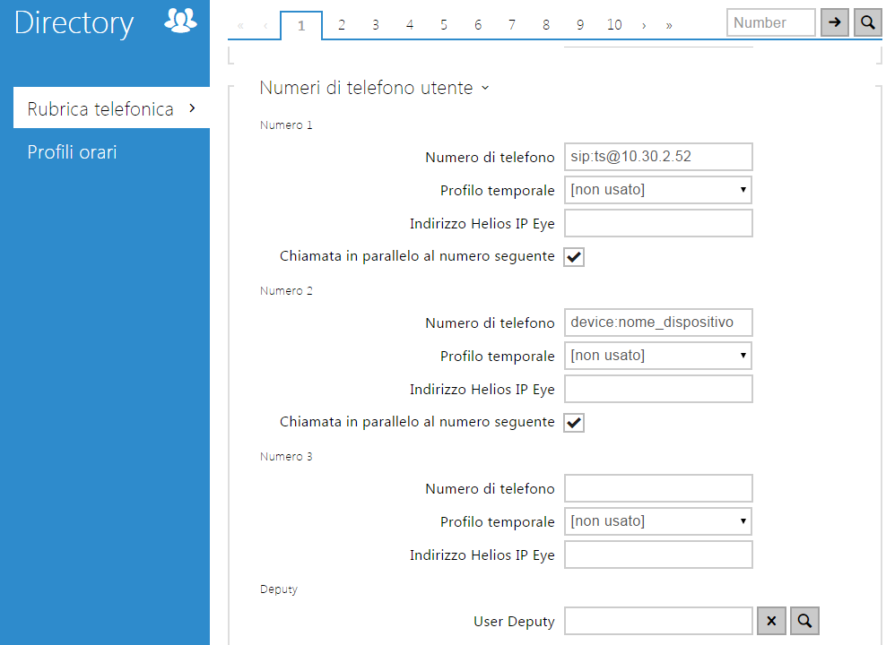
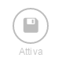
- Enable the parallel call feature;
- Enter the following string into the Telephone Number field:
- device:name _device

where:
name_device is the name that will be set in your mobile device.
N.B.: Each device must have its own unique name.

- Press the “Activate” button;

APP settings on Mobile Apple devices
To install the APP onto Apple devices:
- Access the Apple App Store and download the 2N® Helios IP Mobile App onto your mobile device;
- Access the configurations of the 2N® APP and set the device name (the same entered into the Video Door Phone as described in point 2 in paragraph 6.1);
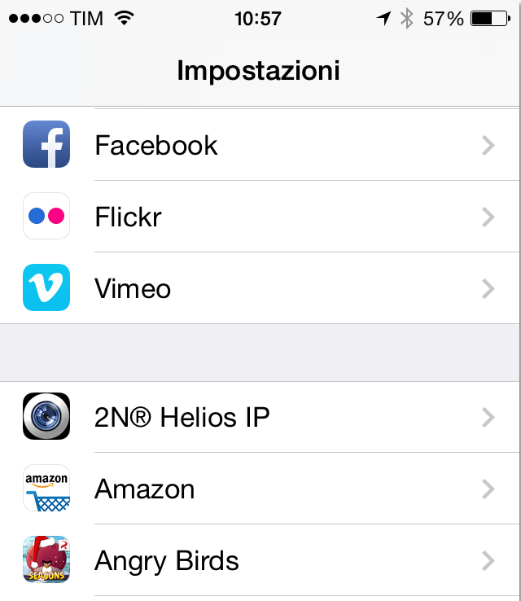
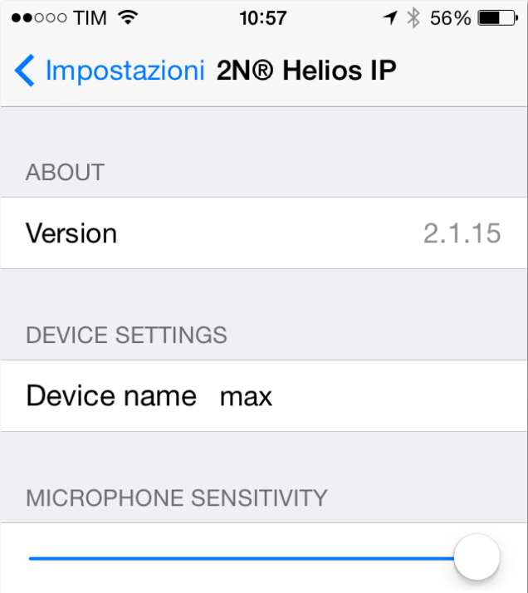

- Enable the Wi-Fi of the feature and connect to a Wi-Fi network that can communicate with the 2N® device;
- Run the 2N® Helios IP Mobile APP;
- Access the “Settings” menu and enter the device name
- Access the Local Network Transport menu and set the “Multicast” feature
- Access the Outgoing Call menu and set the “UDP” feature
- The APP will automatically recognise the Video Door Phone (if communication between the devices is possible) and it will enable three separate operations to be carried out: calling, door opening control, the possibility to listen to the outdoor environment;

APP installation on mobile Android devices
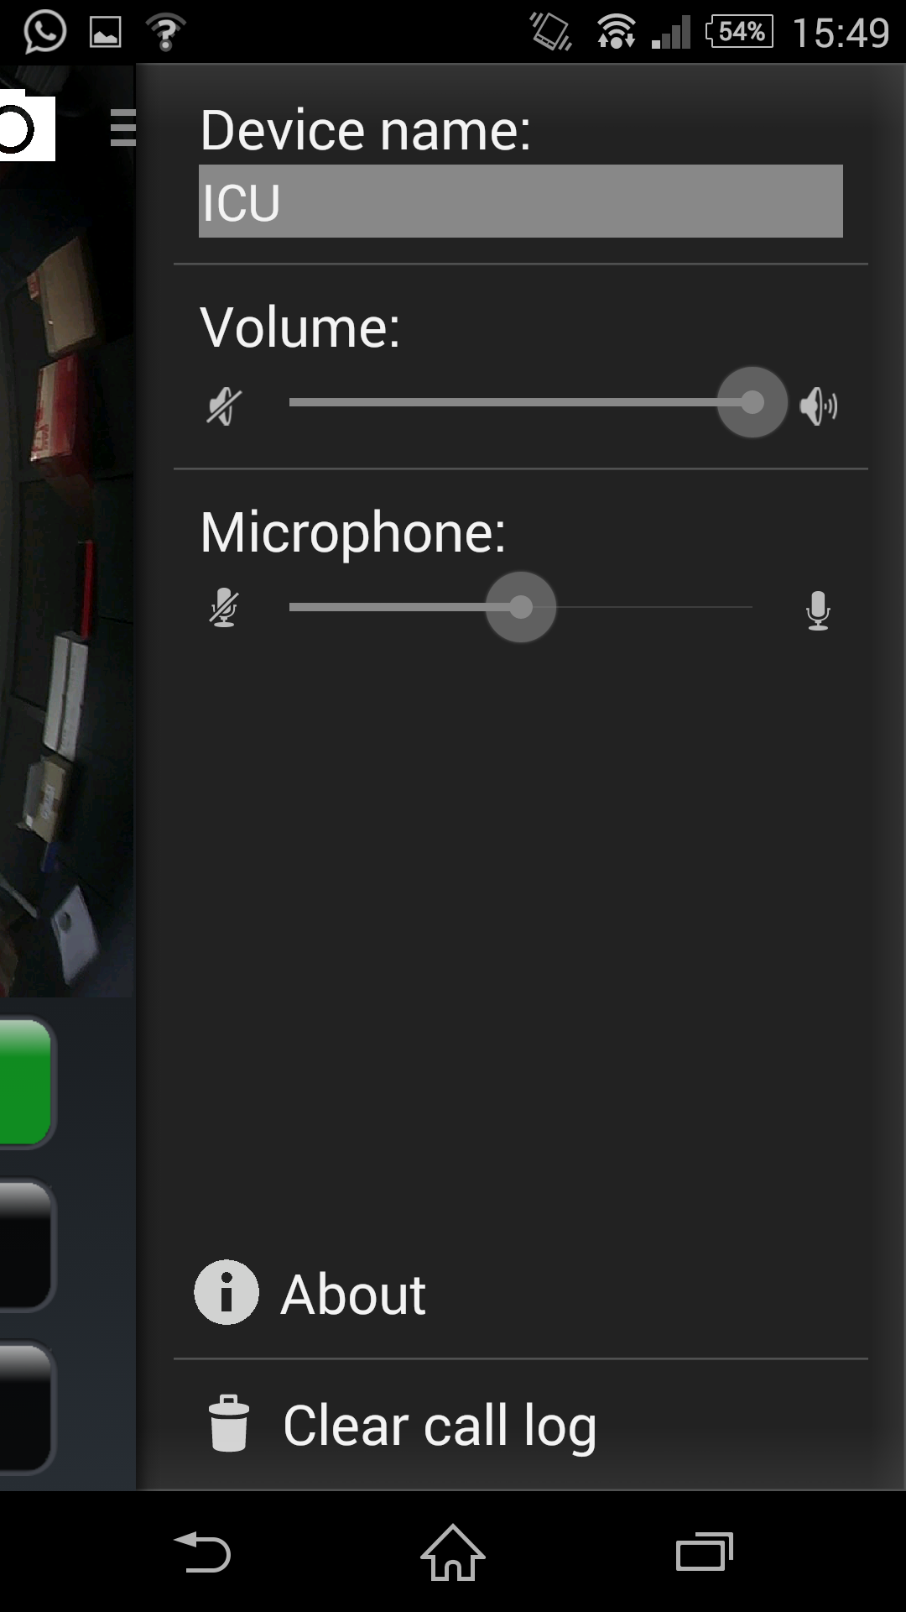
To install the APP onto Android devices:
- Access Google Play Store and download the 2N® Helios IP Mobile APP onto your mobile device;
- Open the app and scroll left to access the “Settings” menu;
- Set an appropriate device name (the same is also to be entered into the Video Door Phone as described in the previous points);
- Select “Multicast” in the “Video” section;
- Activate the Wi-Fi of the mobile device and connect to a Wi-Fi network that can communicate with the 2N® device;
- The APP will automatically recognise the Video Door Phone (if communication between the devices is possible) and it will enable three separate operations to be carried out: calling, door opening control, the possibility to listen to the outdoor environment;

RESETTING OF DEFAULT PARAMETERS

To reset the default parameters of the Video Door Phone, carry out the operations shown below:

- Press the “Reset” button and keep it pressed down throughout the entire procedure;
- Wait for both the red and green LED lights to switch on (approx. 20 secs);
- Wait for the red LED light to switch off (approx. 5 secs);
- Wait for the green LED light to switch off and the red LED light to switch on again (approx. 5 secs);
- Wait for the red LED light to switch off (approx. 5 secs);
- Let the “Reset” button go.

AVE TOUCH SCREEN CONFIGURATION

The configuration of the AVE Touch Screen to make it possible to receive Video Door Phone calls from the 2N® outdoor station is shown below:
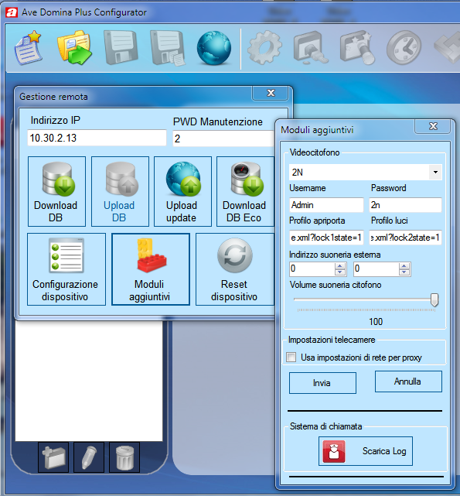
- Connect the PC onto the same LAN network as the Touch Screen;
- Run the “Domina Plus Configurator” program (Ver. 1.0.1.59 or a subsequent version) to configure the Touch Screen;
- Click on the “Remote Management” button (globe icon), enter the IP address, enter the Password (default=2) and click on the “Additional Modules” button;
- Select:
- Video Door Phone: 2N
- Username: Admin
- Password: 2n
- Door opening profile: enu/lockstate.xml?lock1state=1
- Lights profile: enu/lockstate.xml?lock2state=1
- Specify the address of a possible home automation light actuator to be used as a control for an additional ringer (maximum address 7F, leave it as 00 if not already in use);

If an “IP-Camera” device, to which the address of the 2N® Video Door Phone is associated is entered in the touch screen database, it will be possible to view the images coming from such device.
Moreover, in the “IP-Camera” device parameters, it is possible to enter the string of the door opening button to allow the enabling of the corresponding relay on the 2N® device.
The data to enter into the AVE Domina Plus configurator during the configuration of the camera device is as follows:
- Username: Admin
- Password: 2n
- IP address
- Local URI Suffix: enu/camera640x480.jpg
- Door opening profile: enu/lockstate.xml?lock1state=1
- Lights profile: enu/lockstate.xml?lock2state=1

GATE AND LIGHTS OUTPUT CONNECTION

From the Touch Screen it is possible to control the OUT1 (Touch Screen Door Opening Profile) and RELAY1 outputs (Touch Screen Lights Profile) present on the 2N® Video Door Phone.
The OUT1 output is a voltage output controlled by a transistor.
The RELAY output is a change-over output controlled by a relay with potential free contacts (associated by default with switch 1)

